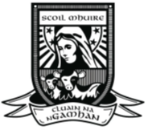
Scoil N. Mhuire,
Cloneygowan,
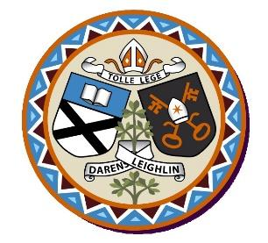
Annual Admission Notice
in respect of admissions to the 2024/2025 school year

Admission Policy and Application Form
A copy of the school’s Admission Policy and the Application Form for Admission for the 2024-2025 school year is available as follows: –
To download at: www.cloneygowanns.ie
On request: By emailing; info@cloneygowanns.ie or by writing to Scoil N. Mhuire, Cloneygowan, Tullamore, Co. Offaly, R35NP58 or by telephoning 0579343594

Part 1 - Admissions to the 2024/2025 school year

Application and Decision Dates for admission to 2024/2025
The following are the dates applicable for admission to Junior Infants

The school will commence accepting applications for admission on | 08/01/2024
The school shall cease accepting applications for admission on | 26/01/2024
The date by which applicants will be notified of the decision on their application is | 09/02/2024
The period within which applicants must confirm acceptance of an offer of admission is | 23/02/2024

Note: The school will consider and issue decisions on late applications in accordance with the school’s Admission Policy.

*Failure to accept an offer within the prescribed period above may result in the offer being withdrawn

Special Class Application and Decision Dates for admission to 2024/2025
The following are the dates applicable for admission to the school’s Special Class which caters for children with a diagnosis of Autism (ASD)
The school will commence accepting applications for admission to the special class on | 08/01/2024
The school shall cease accepting applications for admission to the special class on | 23/02/2024
The date by which applicants will be notified of the decision on their application for admission to the special class is | 05/03/2024
The period within which applicants must confirm acceptance of an offer of admission is | 13/03/2024

Number of Places being made Available in 2024/2025

The number of places being made available in junior infants | 30
The number of places being made available in the special class* catering for children with a diagnosis of Autism (ASD) is | 2 at present

Part 2 - Admissions to the ASD CLass in 2023/2024

In respect of the 2023/2024 school year, the total number of applications for admission received by the school was 1.
Breakdown of places allocated for the 2023/2024 school year:
Number of places available: | 0
Number of applications received: | 1
Number of Offers made and accepted under each criteria: | 0
Total number of offers made | 0
Number of names placed on the waiting list for the school year concerned. | 0

